EX.NO: 09 JavaServer Pages Standard Tag Library
DATE:

AIM:
To develop a program using jsp & its standard library tags such as core, function for the given Question.

Assume you have a list of Country objects, each with the following properties: name, capital, currency, and population. Using JSTL core and formatting tags, create a table that displays the country information and highlight the top three population in red color.
ALGORITHM:
Step 1: Create a Java class with country details with set & get methods under the package. Here Country
Step 2: Create jsp file & by using Jsp tags create a ArrayList of countries
Step 3: Sort that ArrayList & use pageContext.setAttribute
Step 4: Using jstl core tag, iterate over each element
4.1: If the index is less than 3, set class as highlight, otherwise print as it is.

CODE:
Country.java public class country {
String name, capital, currency; int population; public country(String name,String capital,int population,String currency){ this.name=name; this.capital=capital; this.population=population; this.currency=currency;
}
public String getName() { return name; } public String getCapital() { return capital; } public String getCurrency() { return currency; } public int getPopulation() { return population; } public void setName(String name) { this.name = name; } public void setcapital(String capital) { this.capital = capital; } public void setcurrency(String currency) { this.currency = currency; } public void setpopulation(int population) { this.population = population; }
}

Country.jsp
<%@ page contentType="text/html" pageEncoding="UTF-8"%>
<%@ page import="java.util.*"%>
<%@ page import="country.country" %>
<%@ taglib uri="http://java.sun.com/jsp/jstl/core" prefix="c" %>
<%@ taglib uri="http://java.sun.com/jsp/jstl/fmt" prefix="fmt" %>

<!DOCTYPE html>
<html>
<head>
<title>country</title>
<style>
th{ font-size: 24px; padding: 25px; } td{ font-size: 20px; padding: 10px: }
.highlight{ color: red; }
</style>
</head>
<body> <center>
<h1>Country Table</h1><br><br>
<table border="2px solid" style="border-collapse:collapse">
<tr id="tr">
<th>Name</th>
<th>Capital</th>
<th>Population</th>
<th>Currency</th>
</tr>
<% ArrayList<country> country1 = new ArrayList<country>();

country1.add(new country("India","Delhi",10980041,"Rupee")); country1.add(new country("China","Beijing",15000000,"Yuan")); country1.add(new country("USA","Washington",20340089,"Dollar")); country1.add(new country("Brazil", "Brasília", 2120700,"BRL")); country1.add(new country("Italy", "Rome", 2320910,"Euro")); country1.add(new country("Russia", "Moscow", 14395708,"Russian ruble")); Collections.sort(country1, new Comparator<country>() { public int compare(country c1, country c2) { return c2.getPopulation() - c1.getPopulation();
}
});
pageContext.setAttribute("c", country1);
%>
<c:forEach var="coun" items="${pagescope.c}" varStatus="loop">
<tr <c:if test="${loop.index < 3}"> class="highlight"></c:if>>
<td>"${coun.name}"</td>
<td>"${coun.capital}"</td>
<td>"${coun.population}"></td>
<td>"${coun.currency}"</td>
</tr>
</c:forEach>
</table> </center>
</body>
</html>
OUTPUT:
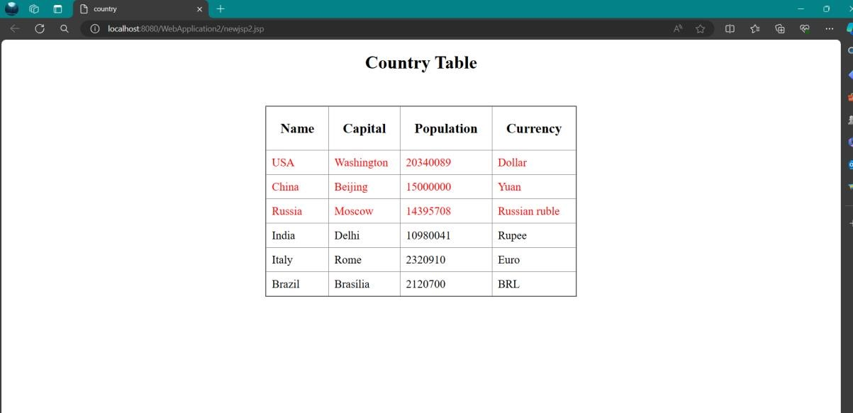

Code/Output (20)
Quiz (5)
Record (5)
Total (30)
Initial

RESULT:
Thus, a program is developed for the given problem using JSTL concepts & was executed successfully.

